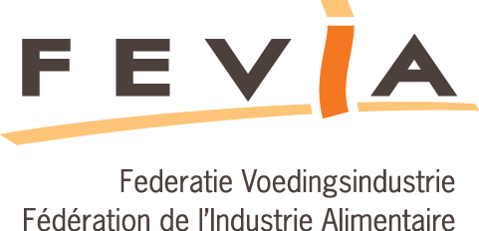

# Objectives Prevention plan Packaging 2016-2019

|  |  |  |  |
| --- | --- | --- | --- |
| **Type of measure** | **Number of companies that have planned this type of measure** | **Number of measures of this type that have been planned** | **Total packaging weight related to this type of measure [ton]** |
|  | **Measures for primary/secundary packaging** | | |
| 1A: Reduction of the amount of packaging | 84 | 139 | 4.521 |
| 1B – Maintain – Maintaining the proportion of reusable packaging | 11 | 14 | 1.022 |
| 1B – Increase: Increasing the proportion of reusable packaging | 28 | 30 | 198 |
| 1C: Improving the quality of packaging on an environmental level | 34 | 44 | 753 |
| 1D: Other prevention measures | 27 | 29 | 1.213 |
| 3A: Various | 70 | 171 | 1.868 |
| 4: Measures for type B packaging | 30 | 58 | / |
|  | **Measures for tertiary packaging** | | |
| 2A: Reduction of the amount of packaging | 43 | 53 | 527 |
| 2B: Increasing the proportion of reusable packaging | 15 | 15 | 276 |
| 2C: Improving the quality of packaging on an environmental level | 4 | 4 | 574 |
| 2D: Other prevention measures | 10 | 12 | 869 |
| 3B: Measures regarding logistic improvement | 46 | 51 | 5.030 ton  993.825 km |