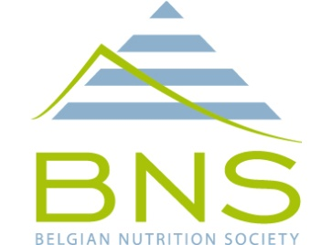
BNS – sponsoring 2017

The Belgian Nutrition Society (BNS) is soliciting private partners for sponsorship in support of its scientific activities to be organized in 2017.
This note briefly explains what such sponsorship encompasses.

Official BNS sponsorship in 2017 will offer acknowledgements (according to the official BNS sponsoring policy as detailed on the BNS website http://belgiannutritionsociety.be/data/userfiles/File/guidelines-for-sponsorship-and-funding-of-BNS.pdf ) and visibility for sponsors at two major scientific events.
- A joint Belgian Nutrition Society / Superior health Council / Institute of Public Health symposium on the importance and use of the recently updated dietary reference values (DRV) for Belgium.
This symposium will host a state of the art keynote lecture on the science behind nutrient reference values, presentations on the most important novelties in the 2016 edition of the Belgian DRV, on the gap between theory and practice and on the use of DRV to develop food based dietary guidelines.
In addition, a number of stakeholders will get a forum to reflect on their use of the DRV for different purposes (clinical nutrition, dietitians, food industry, catering, etc.)
Date : February 10, 2017
Venue : Royal Library – Brussels city center
- The annual BNS congress to be held on April 21st 2017 also in the Royal Library.
The theme for the 2017 edition will be “sugars, carbohydrates and artificial sweeteners”
Final program for this event will be available at the end of 2016.
For further details or questions please contact the BNS secretary Prof. Kristin Verbeke at kristin.verbeke@kuleuven.be or 016 330150.

Thank you in advance for your support!

The BNS Board

